Sponsorship Application Form
I/We hereby offer sponsorship to the 134th Sykehouse Show to be held at
Sykehouse (DN14 9AS) on Sunday 4th August 2019
Name of Company … … … … … … … … … … … … … … … … … … … … … … … …
Address … … … … … … … … … … … … … … … … … … … … … … … … … … … … …
… … … … … … … … … … … … … … … … … … … Post Code … … … … … … … … …
Telephone No … … … … … … … … … … … … … … … … … … …
Contact Name … … … … … … … … … … … … … … … … … … …
Please tick appropriate box
I/We wish to continue sponsorship the same as in previous years
I/We wish to increase my sponsorship to £ … … … … … ….

I/We wish to increase my sponsorship by £10 to include a listing on the
Sykehouse Show Facebook page and Website to £ … … … … … ….

I/We wish to be Patron/s of the Show
Please contact me to discuss changes to my/our sponsorship
Please indicate which class/area you prefer your sponsorship is to be placed with
… … … … … … … … … … … … … … … … … … … … … … … … … … … … … … …
On receipt, an official invoice will be sent in respect of your sponsorship.
Alternatively a cheque made payable to Sykehouse Show may be sent with this form and a receipted invoice will be issued.
Total £ … … … … … … Advertising copy enc / to follow
Please return to: Mrs C Smith, Sponsorship Secretary, Salix, Rudgate Lane, Sykehouse, GOOLE, DN14 9AF, Email: sponsorship@sykehouseshow.org.uk - Assistant Mrs N Loftus -Email: loftusnatalie@yahoo.co.uk
THE SYKEHOUSE SHOW
HELD ON THE FIR ST SUNDAY IN AUGUST

Sykehouse Show Society Founded in 1884
Charitable Incorporated Organisation 1162603

134rd SYKEHOUSE SHOW
SUNDAY 4th AUGUST 2019
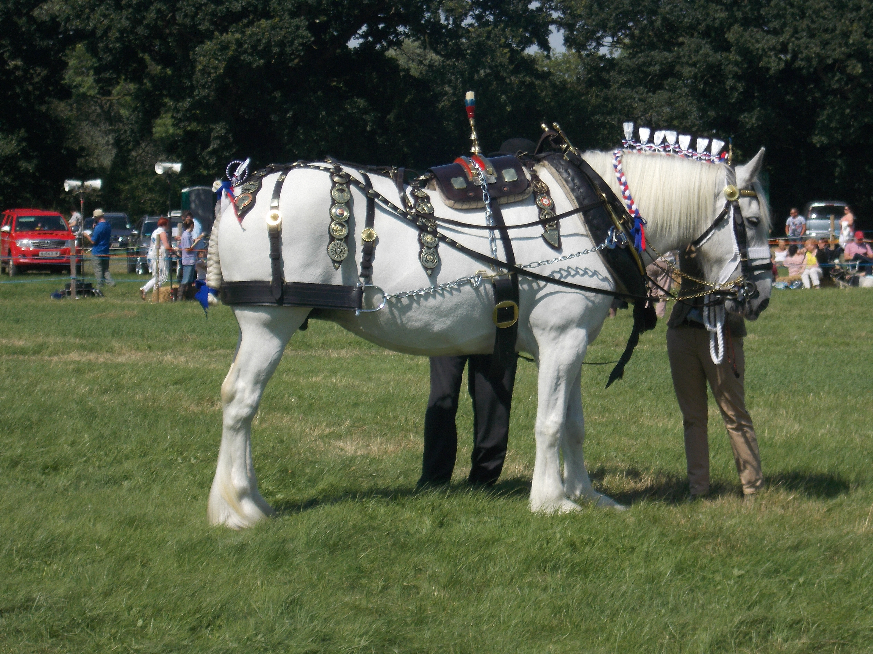

SPONSORSHIP

&

PATRONAGE

From strength to strength
Our show continues to grow and we are keen to make this year a continuation of this achievement. We endeavour to ensure that all aspects of both urban and rural life are on display at this traditional village show. The high calibre of entries across an extensive range of categories helps to make this event such a success in a diminishing show environment and provide a unique opportunity to showcase your business. Visitors and exhibitors from a wide demographic area enhance the advertising potential of the Show.
Why do we need sponsorship?
The Society is a purely voluntary organisation whose principal aim is to arrange an annual agricultural show exhibiting a range of rural activities. Sponsorship enables us to hold down admission prices wherever possible, and thus attract more visitors to the show, despite an annual increase in costs. Sponsorship can be in various forms – in cash or in kind – and the Show offers many ways of putting your name before the public. This can be done by sponsoring either the prize money for Show Classes or other areas within the Show which may be more suitable for your organisation. Sponsorship from Businesses enhances the stature and prestige of the show. In return we can provide an ideal platform for our exhibitors and an enjoyable day out in attractive surroundings.
In offering sponsorship you can:
- Reach in excess of 3000 consumers. Our target audience is families, who love buying, sampling and participating in all the countryside has to offer.
- Look good by helping to sustain an important facet of our country side traditions and education.
- Showcase goods and talk to customers directly by taking a trade stand.
- Generate brand awareness through opportunities such as programmes, banners, announcements or leaflets.
How your support helps us
We are happy to allocate your sponsorship to the area of the show of most benefit to your organisation. Some examples are:
Main Ring Entertainments or Displays, Prize money and rosettes for classes such as: Unaffiliated Show Jumping, Cattle, Sheep, In hand and ridden Shire Horses, Hunters, & Ponies, Carriage Driving, Static Engines & Vintage Tractors, plus a full range of Arts & Crafts & Horticultural Classes in the two Marquees.
Sponsorship packages can also be arranged to suit individual needs:
The following are some examples of the benefits gained from sponsorship:
£80 or more
A two line entry in the schedule
A full page advertisement in the show catalogue
A complimentary car pass and light refreshments in the Vice President’s Marquee
£50 - £80
A two line entry in the Schedule and Programme
A half page advertisement in the show catalogue
A complimentary car pass and light refreshments in the Vice President’s Marquee
£30 - £50
A two line entry in the Schedule and Programme
A quarter page advertisement in the catalogue
Two complimentary pedestrian admission tickets
£20 – become a Patron
A thank you entry in the Schedule and Programme plus a pedestrian admission ticket

